Hillary Jackson

Applying Deterministic Finite Automata to NHS referrals

COMP 1820 Introduction to Compilers

Contents

Introduction: 1

Background 1

Problem Identification: 2

Investigation: 2

Representation: 2

Analysis: 4

Conclusion: 5

References: 5

## Introduction:

Finite automata, categorized as either Non-Deterministic Finite Automata (NFA) or Deterministic Finite Automata (DFA), are examples of abstract machines used in pattern recognition and string processing (Sipser, 2012). While NFAs permit multiple transitions for a single input, DFAs rely on a stricter rule of one-to-one transitions. This investigation delves into the practical application and implementation of DFAs into the NHS doctor referral system, elucidating its deterministic nature in mirroring the referral process.

Background:

The finite automata theory distinguishes between NFAs and DFAs where NFAs provide flexibility with multiple transitions per input. (Sipser, 2012). This means that there can be several different transitions that can be accepted by one input, and it is not just a one-to-one function. They tend to be more flexible as they allow for multiple transitions from a given state to be accepted, but they require further computational steps which can make their diagrams more difficult to create. Whereas DFA’s are a stricter version of a finite machine. At each state, there is only one transition for any input given meaning there are no other routes when transitioning. (Hopcroft et al. 2001).

## Problem Identification:

In the NHS doctor referral system, specifically departments like oncology, a set of strict criteria must be followed to be treated in a department like that and these rules resemble DFAs characteristics due to their deterministic nature. Thus, to solve the problem, DFAs should be implemented to create a seamless referral process resulting in less waiting time (Guseo, R., & Guidolin, M. 2009).

## Investigation:

NHS doctor referrals involve patients meeting certain criteria at various stages for a successful referral. First patients will be required to consult the GP, who asses their condition and will determine if specialist needs are required (Department of Health and Social Care. 2019) Approved referrals will lead to treatment if needed or the referral will be declined. This represents DFAs deterministic nature.

DFAs are preferred over NFAs in this scenario due to their alignment with the process’ rigid criteria. NFAs allow ambiguity in their transitions whereas the referral process requires clear criteria (See Figure 2.) DFAs one-to-one transitions ensure accuracy in modelling, enchaining its efficiency in patient care (See Figure 1.)

## Representation:

Figure 1:

DFA for NHS referral system:

* State 1: Initial state (Consulting GP)
* State 2: Referral submitted.
* State 3: Referral approved.
* State 4: Referral declined.

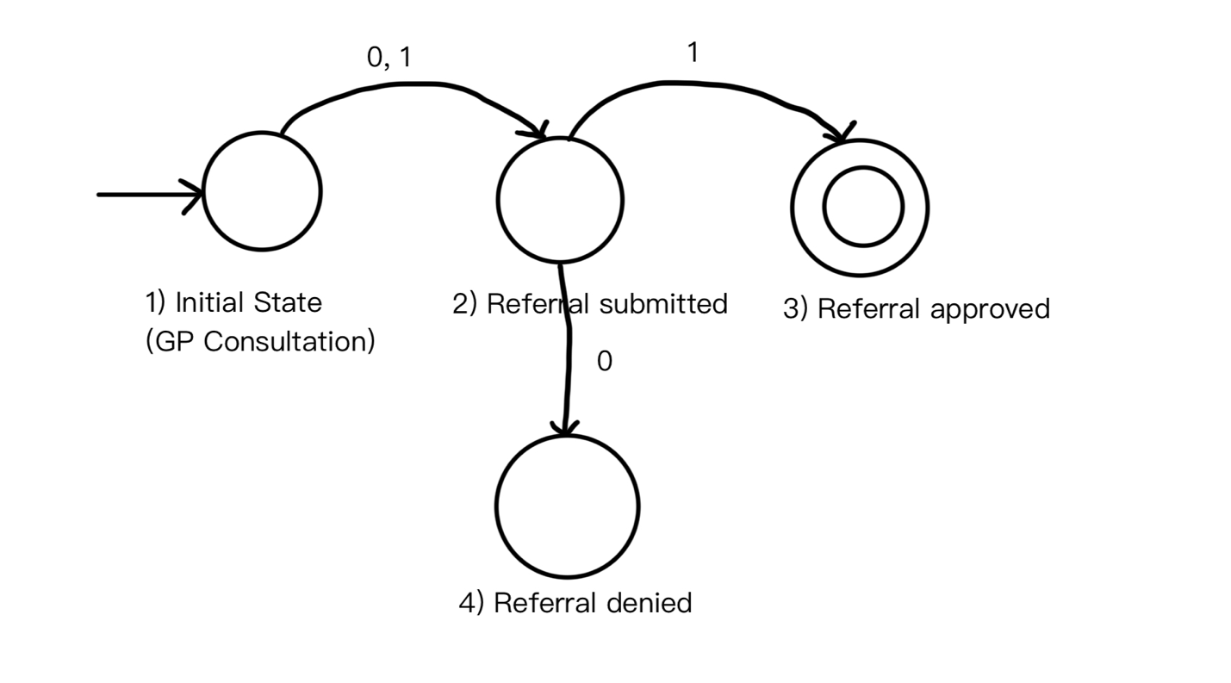

This DFA highlights the NHS referral process in simpler terms, where the patient consults their GP, (State 1) and based on the results of their appointment, a referral will be submitted (State 2) or not. If the referral is submitted and it is accepted (state 3), then the patient will undergo treatment or further evaluations. And in the case where the referral is declined (State 4), then an alternative pathway is taken.

Figure 2:

NFA of the NHS referral system:

* State 1: Initial state (Consulting GP)
* State 2: Referral submitted.
* State 3: Referral approved.
* State 4: Referral declined.

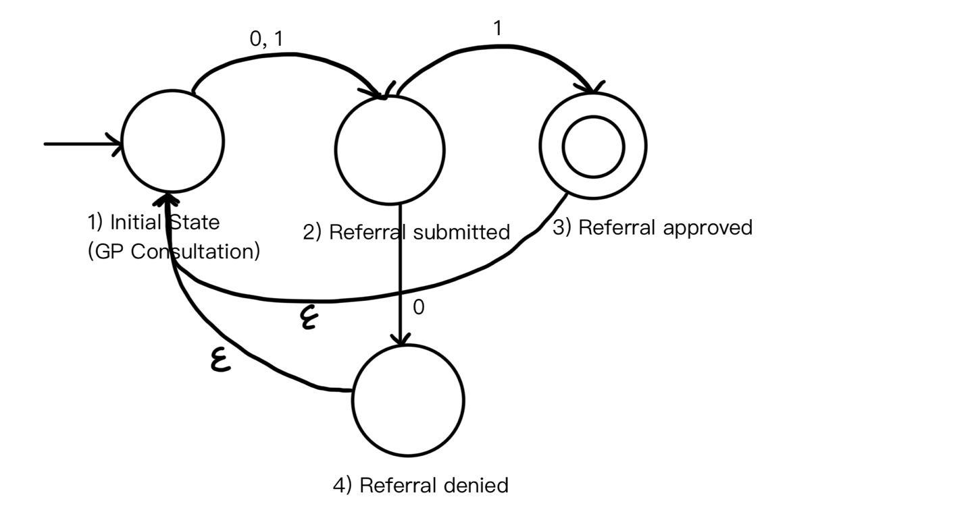

This NFA has epsilon transitions which allow for non-deterministic behaviours. After a referral is approved or denied, the automata can transition to the initial state or any other state without consuming any inputting. This shows a non-deterministic approach however it is not suitable for the NHS referral system because it juxtaposes the strict criteria which must be adhered to.

## Analysis:

DFA’s deterministic nature makes sure that each transition in the referral process follows predefined criteria, akin to the sequential, rule-based progression shown in the NHS referral system (Green and Thorogood, 2004). This alignment ensures reliable and accurate patient care, as the decisions are carried out based on clear criteria at each stage, which helps to reduce any errors that could be easily avoidable.

By applying the principles of DFAs, the referral process can be aided by removing ambiguity and enforcing clear, deterministic criteria (Hopcroft et al. 2001). This optimization reduces backlog by speeding the referral process which ensures timely access to specialist care for patients. As of 2024, the current wait time in the UK is 62 days (about 2 months) from when a doctor's appointment takes place (Cancer Research, 2024)

## Conclusion:

Finite automata, in particular Deterministic Finite Automata (DFA), provide a suitable and accurate framework that mirrors deterministic behaviors depicted in real-world systems like the NHS referral system. DFAs exemplify their utility beyond theoretical constructs by aligning with the firm criteria of the NHS referral process. This in turn illustrates the role of DFAs in optimizing complex real-world systems and applications, like health care (Aldhizer, G. R., & Juras, P., 2015)

## References:

Sipser, M. (2012). Introduction to the Theory of Computation. Cengage Learning.

Hopcroft, J. E., Motwani, R., & Ullman, J. D. (2000). Introduction to Automata Theory, Languages, and Computation. Addison-Wesley.

NHS England. (n.d.). Referral to treatment (RTT) waiting times. <https://www.england.nhs.uk/statistics/statistical-work-areas/rtt-waiting-times/>

Department of Health and Social Care. (2019). The NHS Constitution for England. <https://www.gov.uk/government/publications/the-nhs-constitution-for-england>

Green, J., & Thorogood, N. (2018). Qualitative Methods for Health Research. Sage Publications.

Aldhizer, George R; Juras, Paul. Improving the Effectiveness and Efficiency of Healthcare Delivery Systems. The CPA Journal; New York Vol. 85, Iss. 1, (Jan 2015): 66-71

Guseo, R., & Guidolin, M. 2009. Modelling a dynamic market potential: A class of automata networks for diffusion of innovations. Journal Name, Volume 76 Issue 6, Page 806-820